**EX 9 : DICTIONARY**

**Aim:To implement the knowledge on dictionaries**

**1.Create a dictionary with the city name and its corresponding pin code. Write a python code to retrieve the pin code given the city name.**

**PROGRAM**

dict={"KALAVAKKAM":603110,"VENNAIMALAI":639006,"GUINDY":603102,"AATHUR":629002}

city=input("Enter the city name:").upper() print("The pincode of {} is {}".format(city,dict[city]))

**OUTPUT:**



**2.Create two lists storing the names of the persons in L1 and age of the corresponding person in L2 . Write a Python program to convert them into a dictionary in a way that item from list1 is the key and item from list2 is the value.**

**PROGRAM :**

L1=["Kanika","Boomika","Srika","Sethu","Shibhika","Veni"] L2=[17,18,20,40,35,21]

Dict=dict(zip(L1,L2)) print(Dict)

**OUTPUT”**

**3.Write a Python program to combine two dictionary adding values for common keys. d1={'a':100,'b':200,'c':300}**

**d2={'a':300,'b':200,'d':400}**

**Infer the output of the new dictionary**

**Display only the keys of the new dictionary**

**Display only the values**

**Display the key_value pair**

**PROGRAM :**

d1={'a':100,'b':200,'c':300}

d2={'a':300,'b':200,'d':400}

new_dict={} for i in d1:

if i in d2: new_dict[i]=d1[i]+d2[i]

else:

new_dict[i]=d1[i] for j in d2:

if j not in new_dict: new_dict[j]=d2[j]

print(" (a) New dictionary : ",new_dict) print(" (b) Only keys : ",new_dict.keys()) print(" (c) Only values : ",new_dict.values()) print(" (d) Key value pair : ",new_dict.items())

**OUTPUT :**

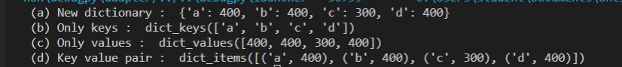

**4. The names of students and a list of GPA’s of two semesters of each student are in the dictionary data structure.**

**Write a function ‘CGPA_stud’ to calculate the CGPA of each student and return the computed information as a new dictionary.**

**Write a function ‘display_names’ that stores the details based on the ascending order of the student names**

**Write a function ‘display_grade’ that stores the details of the student based on the descending order of the CGPA.**

**Display the first three toppers**

**PROGRAM :**

def CGPA_stud(d1):

d={}

for i,j in d1.items():

a=sum(j)//2 d[i]=a

return d

def display_names (a):

asc=sorted(a.items()) return asc

def display_grade(a):

sorted_values=sorted(a.values(),reverse=True) des={}

for i in sorted_values: for j in a.keys():

if a[j]==i:

des[j]=a[j]

return des

d1={}

for i in range(4): name=input("Enter the name : ") marks = []

for i in range(2):

mark = float(input("Enter the mark : ")) marks.append(mark)

d1[name]=marks print(d1) a=CGPA_stud(d1) print("\nCGPA :\n",a) b=display_names(a)

print("\nBased on student name :\n",dict(b)) c=display_grade(a)

print("\nBased on CGPA :\n",c) d=list(c.keys())

print("\nFirst three toppers :\n",d[:3])

**OUTPUT :**

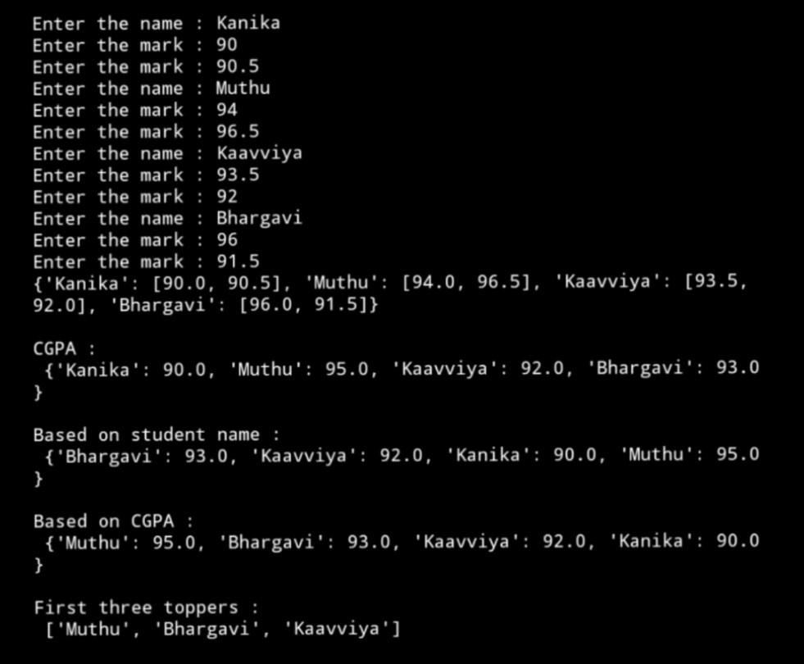

**Create a dictionary for 6 employee details with empno as key, name, dob and net-pay as list of values use appropriate dictionary methods:**

**Create a dictionary with the above information.**

**Insert a new employee details as the second employee**

**Delete the employee at the 4th position**

**Delete the last employee**

**Increment the salary of all employees by 5%**

**PROGRAM :**

dict={"E001":["VARUN","10/11/1998",25000],"E002":["NAVIN","25/03/1999",30000],"E003":["L AKSHMI","09/06/1997",50000],"E004":["REKHA","15/01/1999",30000]}

print(" (a) Dictionary : \n",dict) dict["E002"]=["SHIBHI","27/08/2000",20000]

print("\n (b) Inseting at position 2 : \n",dict) del dict["E004"]

print("\n (c) Deleting elements at 4th position : \n",dict) del dict["E003"]

print("\n (d) Deleting last element : \n",dict) for key in dict.keys():

List=dict[key] List[2]=List[2]+0.05 dict[key]=List

print("\n (e) Incrementing salary by 5% : \n",dict)

**OUTPUT :**

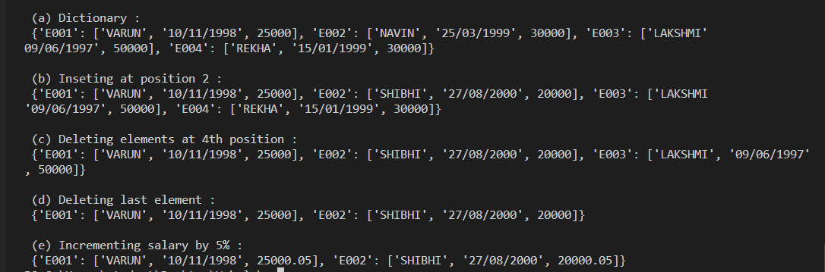

**Consider the student details are maintained using nested dictionary as follows:**

**{Reg no: {subcode: CAT1, CAT2, SAT}}**

**Create nested dictionary for three subjects**

**Display the information of a student given his register number**

**To display the marks of a student given his subject code**

**Update the details of the student given the register number PROGRAM :**

dict={2210211:{"UGE2176":[96,92,99] , "UMA2176":[92,94,97] , "UEN2176":[94,92,95]},

2210406:{"UGE2176":[80,85,82] , "UMA2176":[92,88,95] , "UEN2176":[86,90,95]},

2210626:{"UGE2176":[85,90,93] , "UMA2176":[92,83,97] , "UEN2176":[84,82,95]}}

print(" (a) Nested dictionary : \n",dict) reg_no=int(input("\nEnter the register number:")) print("(b) Student details :",dict[reg_no]) reg_no=int(input("\nEnter the register number:")) sub_code=input("Enter the subject code:") a=dict[reg_no]

b=a[sub_code] print("Marks :",list(b))

reg_no=int(input("\nEnter the register number:")) correct_data=eval(input("Enter the student details as dictionary : ")) dict[reg_no].update(correct_data)

print("Updated :",dict)

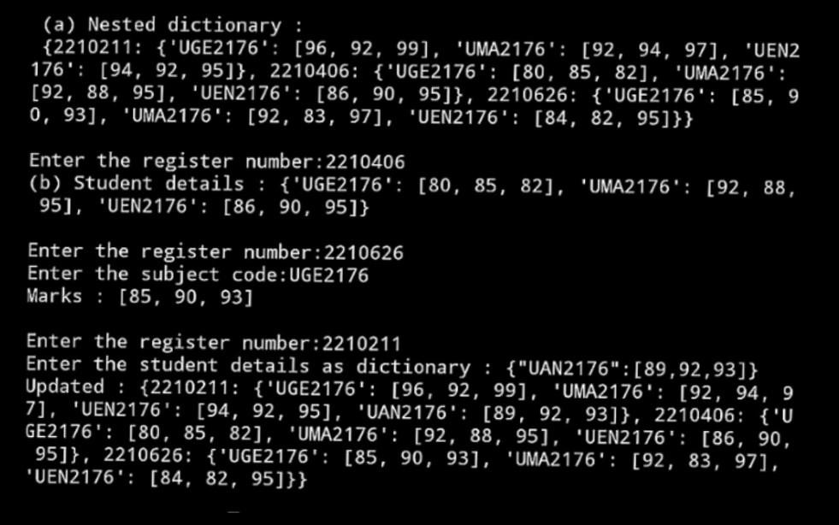**OUTPUT:**

**Write a function that creates and return a dictionary which finds the frequency of occurrence of the characters by obtaining the input string from the user.**

**PROGRAM :**

def Dict(str):

d={}

for i in str:

if i in d:

d[i]+=1

else:

d[i]=1

return d str=input("Enter the string:").lower() print(Dict(str))

**OUTPUT :**



**Learning Outcomes**

<Write down the results in-terms of, i.e what you have done, how you solved the given exercise, what you learnt from the exercise>